**rm command:**

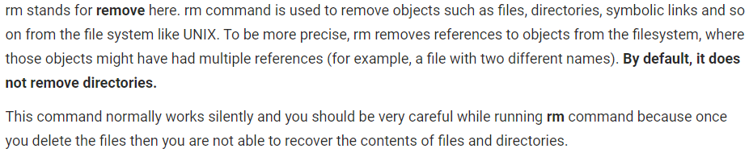

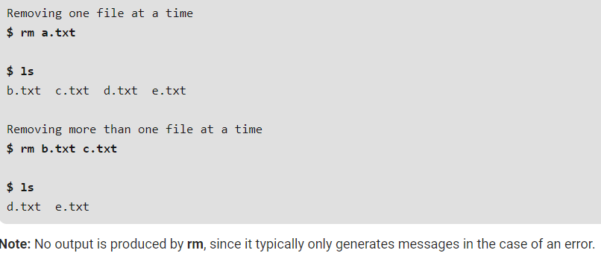

**-i (Interactive Deletion):** Like in cp, the -i option makes the command ask the user for confirmation before removing each file, you have to press y for confirm deletion, any other key leaves the file un-deleted.

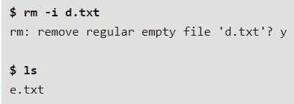

**-f (Force Deletion):** rm prompts for confirmation removal if a file is write protected. The -f option overrides this minor protection and removes the file forcefully.

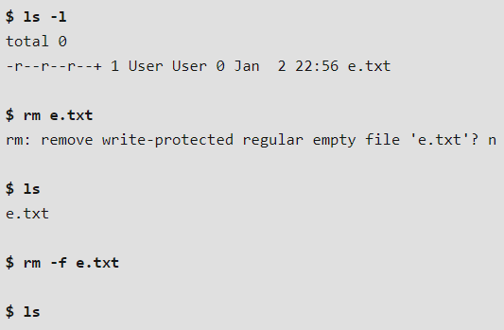

**-r (Recursive Deletion):** With -r(or -R) option rm command performs a tree-walk and will delete all the files and sub-directories recursively of the parent directory. At each stage it deletes everything it finds. Normally, rm wouldn’t delete the directories but when used with this option, it will delete.

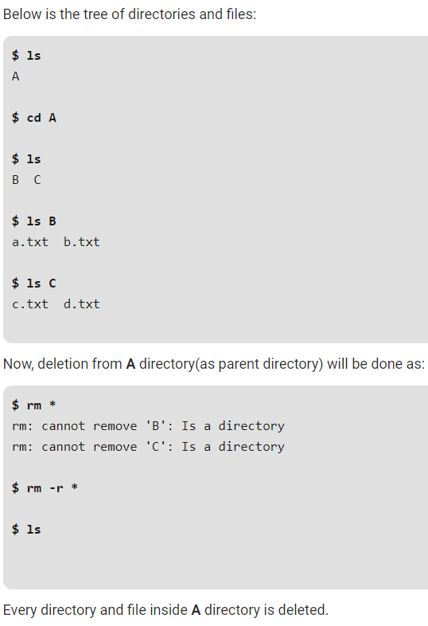

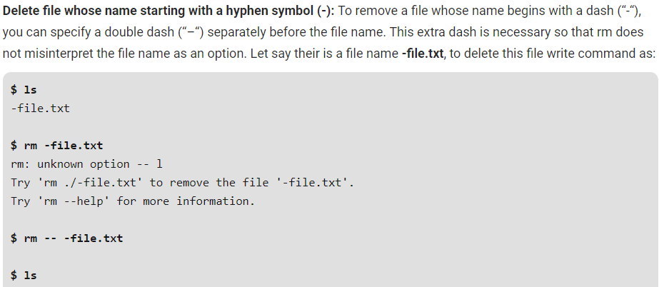

We can also use the below commands

* **rm -rf**
* **rm -ri**

file names starting with dash

